**Carrying the Weight of History: A Little Weight’s Tale of Roman Life and Trade**

In the thriving heart of the Roman Empire, a master artisan once meticulously crafted a steelyard weight. It bore the image of a plump, young emperor, adorned with a laurel-wreath crown and armor featuring a gorgoneion. Though some would later argue that it represented Nero, the true intention of the artisan was to evoke a more generic imperial image (McClanan). The weight, once completed, was destined for a life of adventure and trade, traversing the Mediterranean Sea and playing a crucial role in the Roman economy.

The steelyard weight’s journey began in one of the many bustling marketplaces of Rome, where it was purchased by a successful merchant named Gallus. Gallus recognized the value of the weight, with its finely modeled features and carefully articulated scale pattern on the figure’s armor. The weight would become an essential tool for his business, measuring bulk goods as they were traded between the far-reaching corners of the empire.

As Gallus and the steelyard weight embarked on their journeys together, they witnessed firsthand the Roman economy in action. The weight was slid along the bar of the scale to determine the value of goods such as grain, olive oil, and precious metals (Week 9, Slide 15, 30). With each transaction, the steelyard weight played its part in the exchange of wealth and resources that sustained the empire.

Over time, the weight came to understand the diverse cultures and peoples that made up the Roman Empire. From the opulent villas of wealthy aristocrats to the humble homes of farmers and laborers, it saw the complex tapestry of Roman life unfold (Week 9, Slide 14). It came to know the merchants who traveled with it, their stories of loss and triumph, and the unique ways in which they contributed to the empire’s prosperity.

Years turned to decades, and the steelyard weight found itself in the possession of a new merchant, Lucius, who had acquired it after Gallus’ lost it in a bet while visiting the city of Antioch. Lucius continued to use the weight in his business dealings, preserving its role in the Roman economy. By this time, the steelyard weight had become a witness to history and an unwitting participant in the evolution of the empire. It saw the rise of new emperors and the fall of old ones, the growth of cities and the decline of others, and the changing face of the Mediterranean world (Week 9, Slide 9).

The journeys of the steelyard weight led it to countless ports, where it met other weights bearing the images of empresses and deities such as Athena (McClanan). This vibrant collection of weights, crafted from various shapes and materials, reflected the diversity of Roman small bronzes and the artistic expressions that pervaded the empire. With each new encounter, the steelyard weight became part of a broader story, one that spoke to the interconnectedness of the Roman world.

One memorable journey brought weight to Arabia. There, the weight played a crucial role in a trade negotiation between its owner, Lucius, and a wealthy merchant from India named Aryan. The deal involved a shipment of exotic spices from India, highly sought-after commodities in Rome (The Indo-Roman Spice Trade). Aryan had arrived with his cargo of cinnamon and black pepper, eager to sell his goods at a premium price.

Being a shrewd businessman, Lucius knew the value of these rare spices and was determined to strike a favorable deal. As the two merchants haggled over the price, the steelyard weight silently observed the exchange from its position on the scale. As it was slid along the bar, it determined the value of the spices and ultimately sealed the deal between Lucius and Aryan. The agreement led to a lasting partnership that would benefit both parties for years to come.

Through its travels and encounters, the weight played a small yet significant role in the lives of the people it met. From the bustling markets of Rome to the quiet shores of the Mediterranean, the little weight left a mark on the lives it touched.

However, as with all things, the weight’s time in the sun eventually came to an end. It found itself aboard a ship bound for the eastern reaches of the empire, packed alongside other goods and treasures. But fate had other plans for the steelyard weight. A powerful storm struck the vessel as it sailed near the coast of modern-day Turkey (Sams, 1982, 202-30). The ship, unable to withstand the tempest, sank to the depths of the Mediterranean, taking the weight with it.

Centuries passed, and the steelyard weight lay undisturbed on the sea floor, its story seemingly forgotten by the sands of time. But fortune would once more shine upon it when a team of maritime archaeologists discovered the shipwreck and the treasures it held. Among the artifacts recovered was the steelyard weight, its once-pristine features now worn from the passage of time and the elements (McClanan). Once carefully restored, the weight began a new chapter in its eventful existence.

After a long journey through the hands of collectors and scholars, the steelyard weight eventually found its way to the Harvard Art Museums, where it would be studied and admired by new generations of scholars. Its arrival at Harvard marked the beginning of a new era for the artifact, one in which it would serve as a tangible connection to the past and a source of inspiration for those seeking to understand the complexities of the Roman Empire.

The steelyard weight may no longer travel the Mediterranean or weigh the bulk goods of ancient merchants, but its legacy lives on in the hearts and minds of those who study it. Through their learning, they will shed light on the long-lost tales of the merchants who once relied on the weight, the artisans who crafted it, and the countless individuals whose stories intersected with its own.

And so, the life of the steelyard weight continues as a source of inspiration and knowledge for those who seek to understand the past. Through the eyes of each new generation, the weight’s story will be reimagined and reinterpreted. As students continue to explore the weight’s storied past and its place within the broader narrative of the Roman Empire, they will contribute not only to our understanding of history but also to the enduring legacy of the artifact itself. For the steelyard weight, its journey from the depths of the Mediterranean to the halls of Harvard is a testament to the enduring power of history and the stories we tell about it – a legacy that will undoubtedly continue for generations to come.

[**2012.1.97: Emperor Bust Weight (Measuring Devices)**](https://harvardartmuseums.org/collections/object/54472)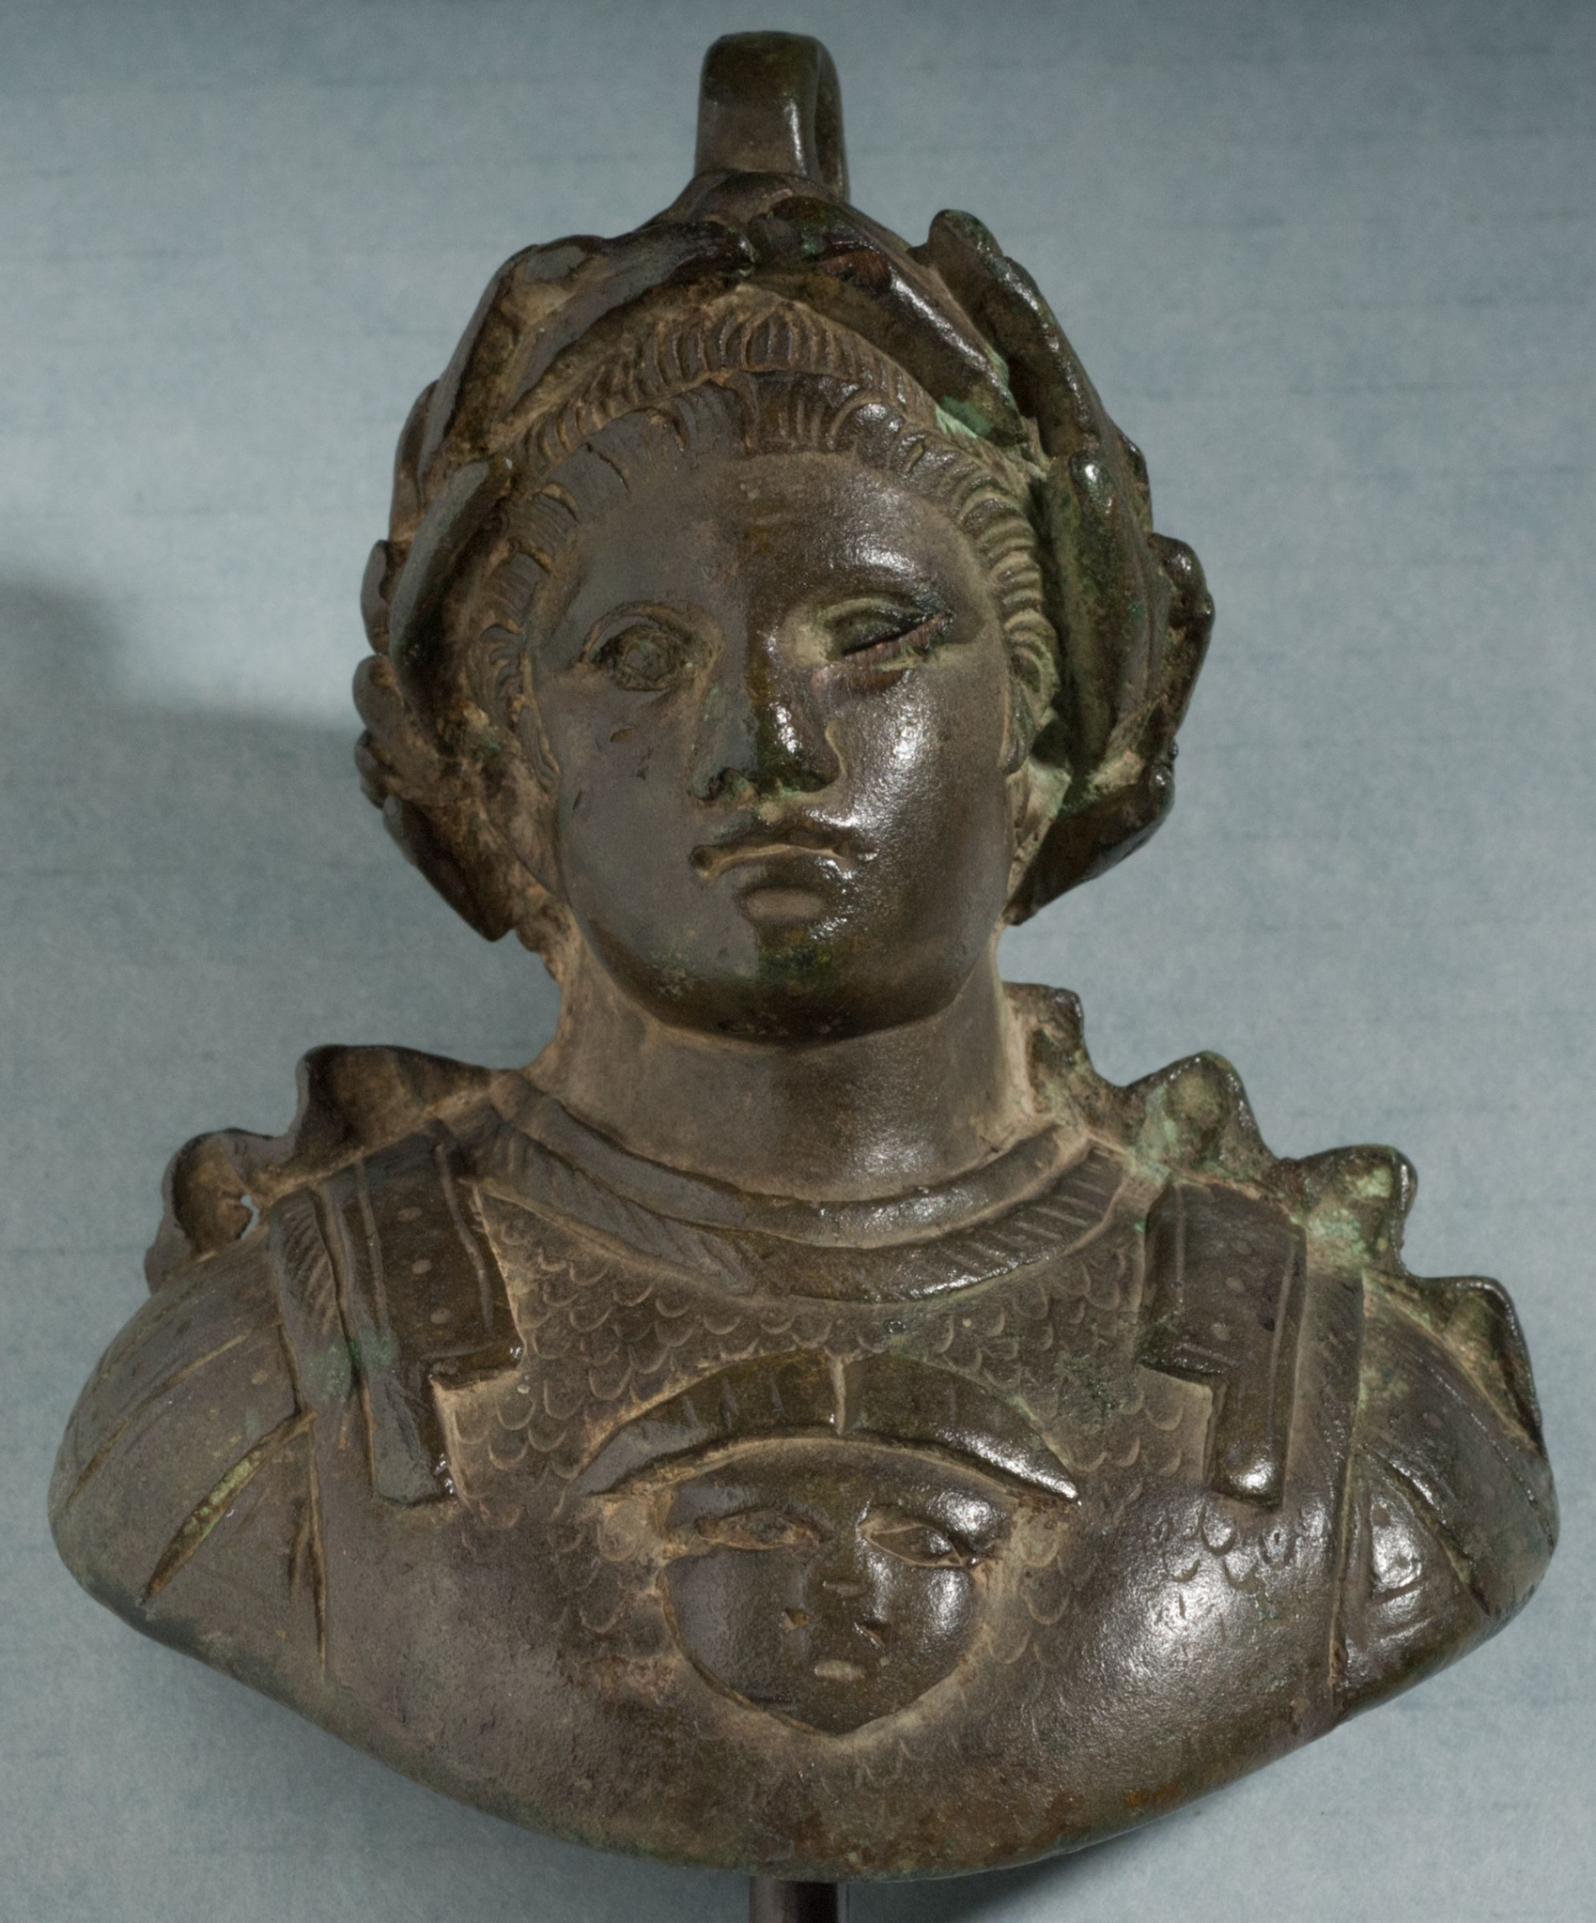

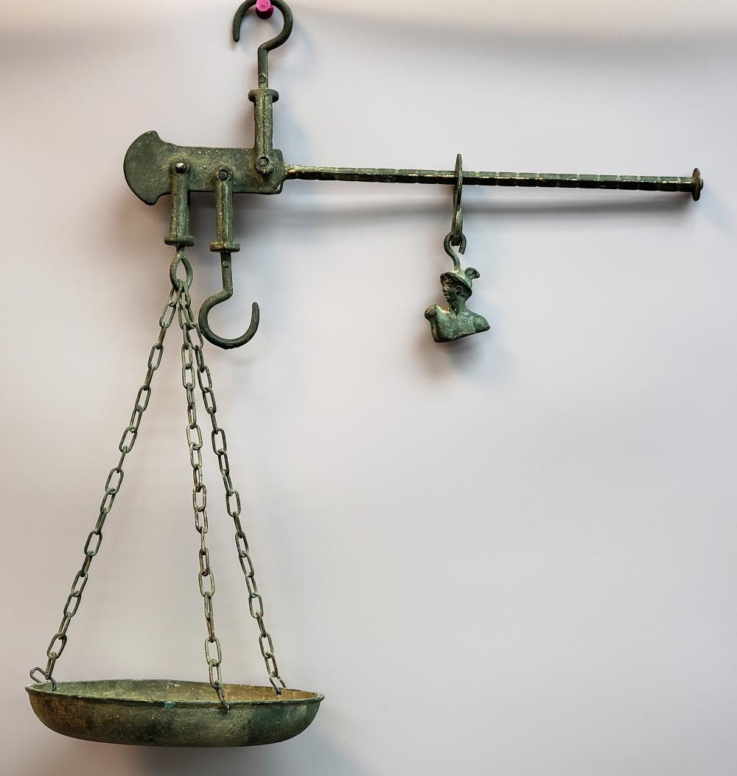

**Example of a Roman-era scale like the one that would have used the weight**

**References**

McClanan, A. L. (n.d.). *2012.1.97: Emperor Bust Weight*. Harvard Art Museums. Retrieved April 25, 2023, from <https://harvardartmuseums.org/collections/object/54472>

Sams, K. G. (1982). The Weighing Implements. In G. F. Bass & J. Doorninck (Eds.), *Yassi Ada: A Seventh-Century Byzantine Shipwreck* (202-30, 224). <https://www.academia.edu/36950925/1982_YASSI_ADA_Vol_I_A_Seventh_Century_Byzantine_Shipwreck>

The Indo-Roman Spice Trade. <https://foodanddining.omeka.net/exhibits/show/spicesoftheancientromanworld/the-indo-roman-spice-trade>